# **HEALHAVEN**

Website for Disease Solutions

**A MINI-PROJECT REPORT**

Submitted By

**SANJEEV KANTH S 220701250**

in partial fulfilment of the award of the degree

of

**BACHELOR OF ENGINEERING**

**IN**

**COMPUTER SCIENCE AND ENGINEERING**



**RAJALAKSHMI ENGINEERING COLLEGE AUTONOMOUS, CHENNAI 602105 NOV/DEC,2024**

# ACKNOWLEDGEMENT

I express my sincere thanks to my beloved and honorable chairman MR.S.MEGANATHAN and the chairperson DR.M.THANGAM MEGANATHAN for their timely support and encouragement.

I am greatly indebted to my respected and honorable principal Dr. S.N.MURUGESAN for his able support and guidance.

No words of gratitude will suffice for the unquestioning support extended to us by my head of the department Dr. P. KUMAR, and my Academic Head Dr.R.SABITHA for being ever supporting force during my project work.

I also extend my sincere and hearty thanks to my internal guide Mr.DEEPAKKUMAR KRISHNAMURTHY for his valuable guidance and motivation during the completion of this project.

My sincere thanks to my family members, friends and other staff members of Computer Science and Engineering.

SANJEEV KANTH S (220701250)

**TABLE OF CONTENTS**

|  |  |  |
| --- | --- | --- |
| **S.NO** | TITLE | PAGE.NO |
| 1 | ASBSTRACT | 4 |
| 2 | INTRODUCTION | 5 |
| 3 | SYSTEM SPECIFICATIONS | 7 |
| 4 | DIAGRAMS | 8 |
| 5 | MODULE DESCRIPTION | 10 |
| 6 | IMPLEMENTATION | 13 |
| 7 | CONCLUSION | 14 |

# ABSTRACT

The **"Disease Solutions Website"** is a comprehensive project designed to provide users with a centralized platform to access information about various diseases and their recommended remedies. The system utilizes a MySQL database to store disease names, remedies, video resources, and expert doctor information. Through an intuitive web interface, users can search for diseases using a search bar and retrieve detailed solutions, including textual descriptions, video tutorials, and the credentials of healthcare professionals.

This project combines dynamic web technologies, including HTML, CSS, PHP, and MySQL, to deliver a user-friendly and responsive application. It aims to assist users in identifying appropriate remedies quickly and reliably, enhancing healthcare accessibility. Additional features like search optimization and multimedia integration make the platform a valuable tool for educating users about disease prevention and management.

The system is designed with scalability and adaptability, allowing future enhancements such as categorization of diseases, user feedback integration, and multilingual support to cater to a global audience. Security measures like SQL injection prevention and secure data handling ensure the reliability and safety of the application. By bridging the gap between healthcare professionals and users seeking credible remedies, this project addresses a crucial need in the digital healthcare domain. It not only serves as an educational resource but also promotes awareness and proactive health management through an accessible, interactive, and well-organized platform.

**CHAPTER 1**

**INTRODUCTION:**

Healthcare is a critical domain where access to accurate and actionable information can significantly impact lives. In the digital age, the demand for reliable, centralized, and easily accessible platforms offering disease-specific remedies has grown exponentially. This project, the "Disease Solutions website" aims to bridge this gap by providing users with an interactive, web-based solution for accessing detailed information about various diseases, their remedies, video resources, and expert recommendations. By leveraging modern web technologies and database management, the system ensures that users can conveniently find personalized solutions for managing and preventing diseases.

**SCOPE OF THE WORK:**

The scope of this project includes the development of a dynamic web-based platform powered by a database to manage and deliver remedies for various diseases. The platform will feature:

1. **Search Functionality:** A search bar to allow users to find remedies based on disease names.
2. **Multimedia Support:** Integration of video resources to provide visual guidance.
3. **Expert Information:** Displaying recommendations from healthcare professionals.
4. **User-Friendly Interface:** A responsive design accessible on multiple devices.
5. **Data Management:** A scalable database to store and manage diseases, remedies, videos, and expert information.
6. **Future Expansion:** Support for categorization, user feedback, and additional resources like symptoms or prevention tips.

This system is intended for individuals seeking credible health solutions and healthcare professionals who wish to contribute their expertise.

**PROBLEM STATEMENT:**

The lack of centralized platforms offering reliable disease remedies and expert advice poses a challenge for individuals seeking quick and credible health-related information. Many existing resources are fragmented, outdated, or difficult to navigate, leading to confusion and potential misinformation. Additionally, there is a need for user-friendly tools that provide not only textual remedies but also visual and expert-supported guidance, especially for individuals with limited healthcare access. This project addresses these challenges by developing a robust, scalable, and interactive system that offers comprehensive solutions to improve health awareness and management.

**AIM AND OBJECTIVES OF THE PROJECT:**

The aim of this project is to design and implement a database-driven web platform that provides users with accurate, accessible, and expert-supported remedies for a wide range of diseases.

**Objectives of the Project**

1. **Develop a Centralized Database:** Create a robust database to store detailed information about diseases, remedies, video links, and expert recommendations.
2. **Implement Search Functionality:** Allow users to easily retrieve information using a search bar.
3. **Ensure User-Friendly Design:** Build a responsive, intuitive, and aesthetically appealing interface for seamless navigation.
4. **Integrate Multimedia Resources:** Enhance understanding through video tutorials and guides for remedies.
5. **Provide Expert Endorsements:** Display information from certified healthcare professionals to enhance credibility.

This project aims to be a stepping stone toward improving public access to healthcare knowledge, fostering health awareness, and promoting proactive disease management.

**CHAPTER 2**

**SYSTEM SPECIFICATIONS**

**HARDWARE SPECIFICATIONS:**

The system requires basic hardware to host the website, which can be adjusted based on user load. Recommended hardware specifications include:

• Processor: Minimum Intel i5 or equivalent

• RAM: 8 GB

• Storage: 250 GB (SSD preferred for faster data retrieval)

• Network: High-speed internet connection for reliable connectivity

For local development, any modern laptop or desktop with the above specifications will suffice. However, for production, cloud hosting is recommended to ensure scalability and accessibility.

**SOFTWARE SPECIFICATIONS:**

Operating System: Windows, macOS, or Linux (for local development and testing)

• Web Server: Apache

• Database Management System (DBMS): mySQL, chosen for its reliability and support for complex queries and relationships

• Programming Languages: HTML, CSS, JavaScript (for frontend); Php (for backend processing)

**CHAPTER 3**

**ARCHITECTURE DIAGRAM**

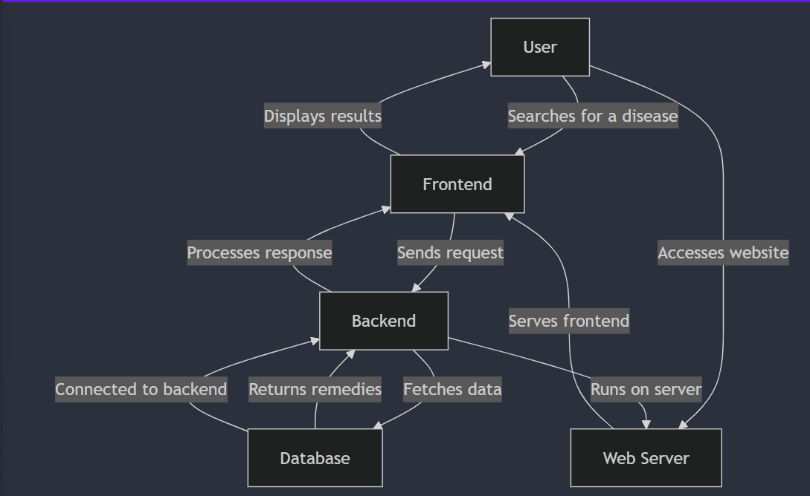

**ACTIVITY DIAGRAM**

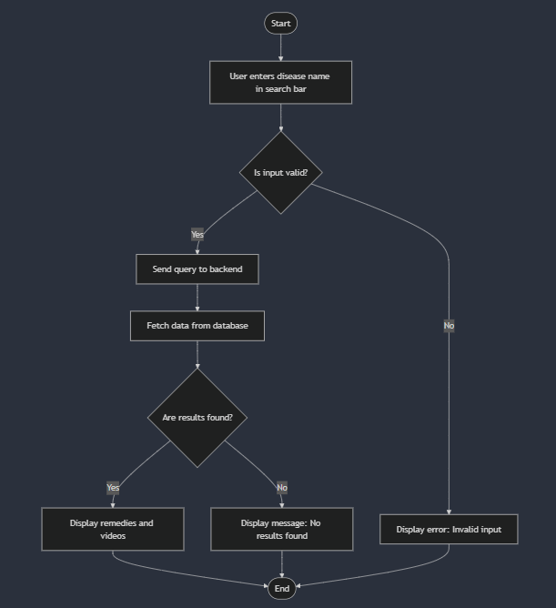

**CHAPTER 4**

**MODULE DESCRIPTION**

**1. User Interface Module**

**Description:**  
This module is responsible for the frontend design and user interaction. It includes the homepage, search bar, and results display, ensuring a user-friendly and intuitive experience.

**Key Features:**

* Responsive design using HTML, CSS, and JavaScript.
* A search form to allow users to input disease names.
* Dynamic display of results retrieved from the backend.
* Navigation menu linking to different pages like "Home," "Solutions," and "Information."

**Technologies Used:**

* HTML5, CSS3, JavaScript.

**2. Search and Query Module**

**Description:**  
This module handles user search requests, processes the input, and interacts with the backend to retrieve relevant data from the database.

**Key Features:**

* Captures search queries from the user.
* Validates input to prevent errors or malicious attempts (e.g., SQL injection).
* Forwards the query to the backend for processing.
* Displays matching results or error messages (e.g., "No results found").

**Technologies Used:**

* JavaScript (frontend), PHP (backend).

**3. Database Management Module**

**Description:**  
This module manages all database operations, including storing, retrieving, and updating data about diseases, remedies, video links, and doctor information.

**Key Features:**

* A relational database schema for efficient data organization.
* CRUD operations (Create, Read, Update, Delete) for managing disease-related information.
* Optimized queries to fetch data quickly based on user searches.
* Data integrity and validation mechanisms to ensure accurate and consistent data storage.

**Technologies Used:**

* MySQL (database), phpMyAdmin (optional for database management).

**4. Backend Processing Module**

**Description:**  
This module acts as the intermediary between the frontend and the database, handling server-side logic and query processing.

**Key Features:**

* Processes search requests from the frontend and queries the database.
* Formats and sends retrieved data back to the frontend for display.
* Implements security measures like escaping input to prevent SQL injection.
* Scalable to support additional functionalities such as advanced search filters or category-based retrieval.

**Technologies Used:**

* PHP (server-side scripting).

**CHAPTER 6**

**IMPLEMENTATION**



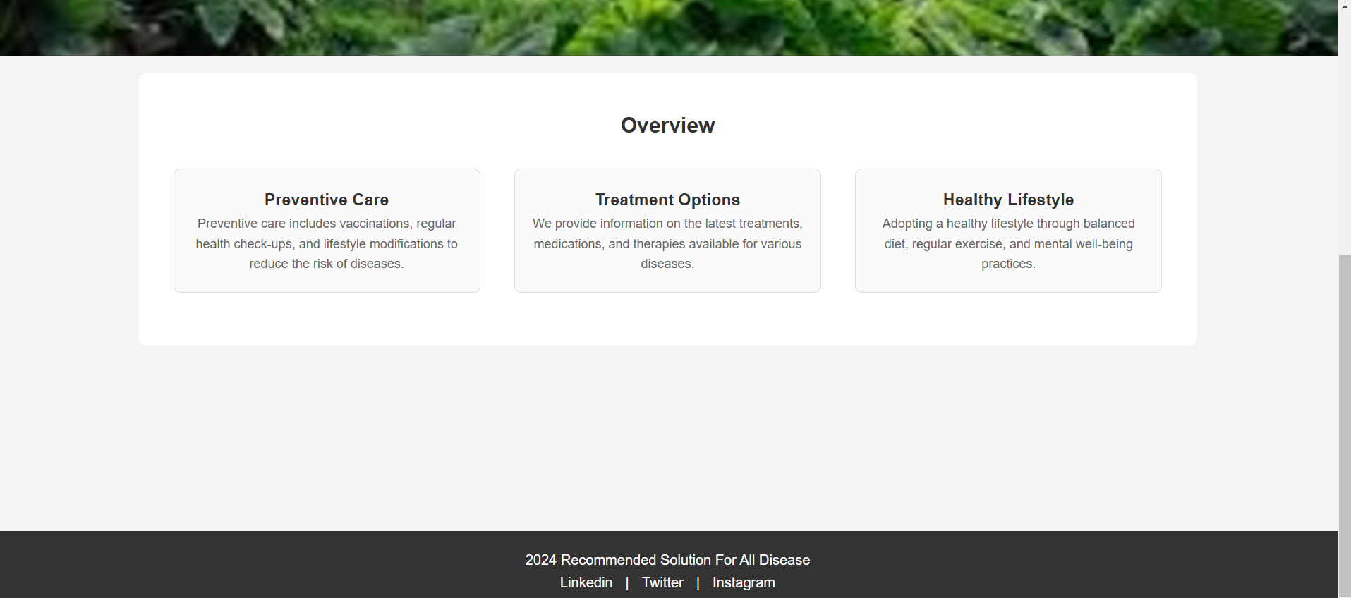

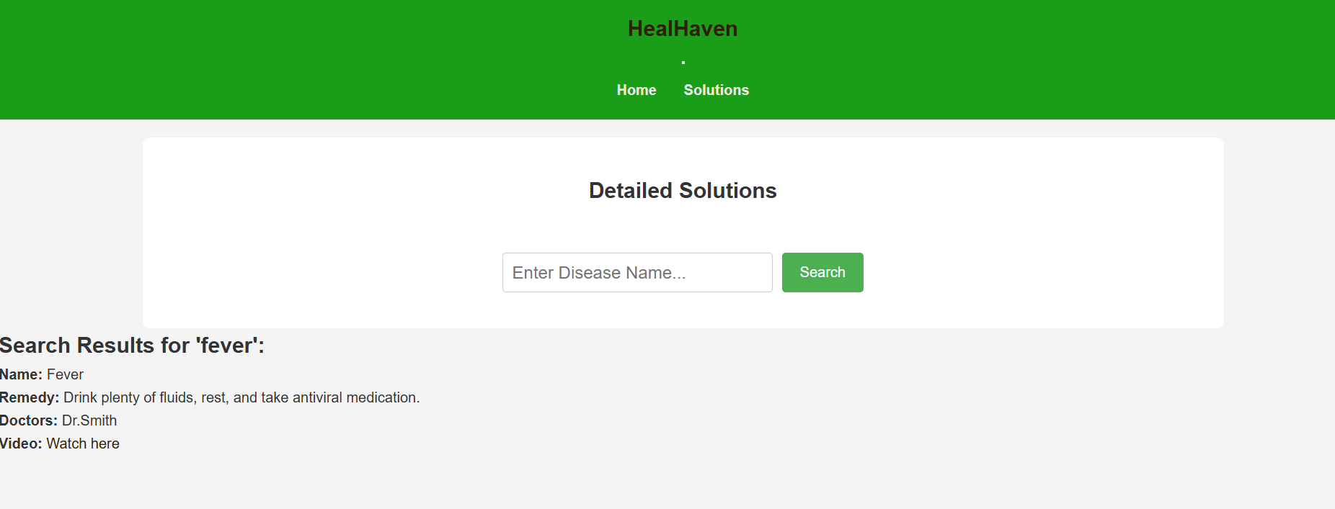

**CHAPTER 7**

**CONCLUSION**

The **"Disease Solutions website"** is a robust, user-friendly web application designed to provide reliable, accessible, and expert-backed solutions for managing and preventing various diseases. Through the use of modern web technologies such as PHP, MySQL, HTML, CSS, and JavaScript, the system effectively bridges the gap between healthcare professionals and users seeking credible health information.

By offering functionalities such as disease search, remedy suggestions, multimedia integration, and expert guidance, the project empowers users to take informed actions toward better health management. The database-driven approach ensures that data is stored efficiently and can be updated or expanded easily to include new diseases, remedies, and expert advice.

The system's modular design allows for future enhancements, such as adding user feedback, expanding disease categories, and integrating additional multimedia resources. The platform provides a valuable tool for users worldwide, making healthcare information more accessible and actionable. The successful development of this project not only addresses a significant need for accessible health solutions but also demonstrates the potential for further innovation in the field of digital health management.

Overall, the project meets its goal of providing an intuitive, scalable, and secure platform for disease prevention and remedy management, laying the foundation for future advancements in health technology.